Version Control System

1. Version Control System is a must in any project to manage code.
2. Version Control System give lots of benefits
   1. Multiple developers can collaborate on same project
   2. It tracks changes happening to the files, it maintains timestamp, user, reason for changing.
   3. It also secures your project code
   4. It also acts like a backup for your code.
   5. Many more advantages..
3. There are several version control systems in the market
   1. Git (Most popular and widely used tool today)
   2. SVN
   3. Perforse
   4. Mercurial
   5. Clear Case

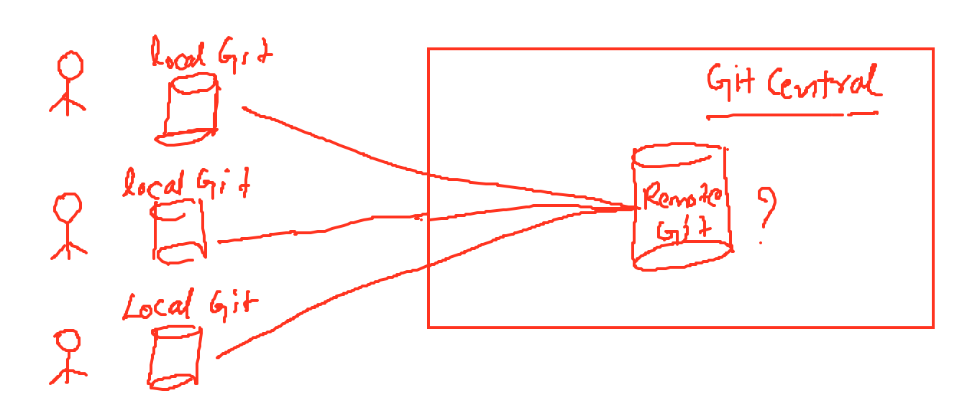

Git Remote Repository

1. This is going to be a central git server for developers to integrate their changes.
2. We can get this in two ways
   1. SaaS (Software as a Service)
      1. Github
      2. Bitbucket
      3. Gitlab
      4. Codecommit
      5. Etc..
   2. Hosted Git
      1. Here we install git on our own servers
      2. Our current customer wants to git on their own servers.

Create account in Github, which is going to be our remote git server

<https://github.com/>

After signing up you get an email, follow that mail to finish the signup process.

Install Git Client

1. For managing project related files on developers local machine he needs git client.
2. Git client comes in couple of categories
   1. CLI (Command Line Interface)
   2. GUI (Graphical User Interface)
3. Install git bash (CLI)
   1. <https://git-scm.com/downloads>
   2. Double click the installer file and click next until it installs the tool.

Create a Demo Project in github

* We wanna learn git so we need a demo project.
* From github, create git repository
* Repository represents a project in git

Add our files to remote repository

The best practice is to make changes to your files in the local and add them to remote.

1. First get git remote repository to local and add your changes to local repo and push to remote repo.
2. Run Git Clone Command
   1. Open git bash
      1. On windows right click → open git bash here
      2. On macbook open terminal
   2. git clone <https://github.com/javahometech/devops123>
   3. This create a folder with name of your repository “devops123”
3. Create a new file and push this file to remote.

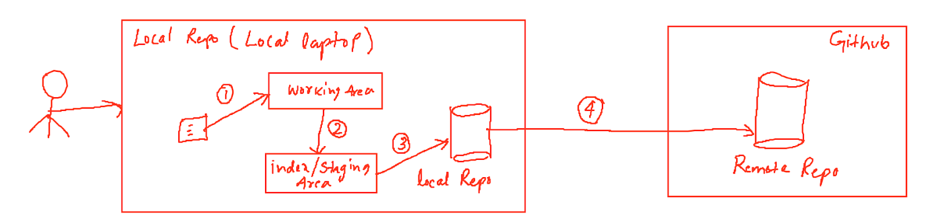

Visual Studio Code

1. Nice tool for devops and other development activities
2. <https://code.visualstudio.com/>
3. Download above tool

Git locally maintains the following

1. Working Area
   1. Working area contains the files which are created/modified/deleted
   2. Working area is virtual, you can't see it as a folder physically.
2. Staging Area
   1. We should put files to staging area before committing them to local repository
   2. git add hari.txt
   3. git add \* (stage all modified files)
   4. git add \*.txt (stage all files ending with txt)
3. Local Repository
   1. git commit -m ‘meaningful commit message’
   2. Commit, commits files in staging to local repository
4. Push changes to Remote
   1. git push origin master
   2. origin is alias name referring to remote repo url
   3. master is the branch we want to push changes to

Configure Name and Email

1. You must configure Name and Email in your local
2. This is used by git client to record commits with your name and email
3. git config --global user.name “Hari Kammana”
4. git config --global user.email “hari.kammana@gmail.com”
5. --global means, the use and email details are same for other git repositories i work on in this machine

Note: Git config file location is ~/.gitconfig

Git Fetch

* Fetch remote changes to local machine and don't merge

Git Pull

* We should always get latest changes from remote before we work on new changes
* git pull origin master
* Git clone is used first time to get the copy to local, after we have local repo, we should use pull.
* Git Pull = Git Fetch + Git Merge

(FAQ) What is the difference between pull and fetch?

Git Push

1. Push local commits to remote.
   1. Git push fails if remote contains commits that is not present in local
2. The idea if before you push your commits to remote you have to merge remote changes and then merge it.

(FAQ) What is conflict in git?

While merging if there are changes in the same file and line, then we get conflicts.

(FAQ) How do you resolve conflicts in git?

* It is resolved manually
* It is resolved using visual studio code (better answer)

Git Log command

1. This command shows commit history in the current branch.
   1. git log
   2. git log --oneline
   3. git log -4 (show recent 4 commits in the history)

Git Status

1. This shows details about our working tree (working are plus staging area)
2. git status

Undoing changes in git

1. Undoing changes in working Area
   1. git restore hari.txt (undo changes in hari.txt)
   2. git restore \* (undo changes in all the files)
2. Undoing changes in Staging area / To unstage a file
   1. git restore --staged hari.txt
   2. git restore --staged \*
3. Undo local commit
   1. Delete local Commit
      1. git reset commit-id
      2. It removes all commits above mentioned commit id from local

(FAQ) What is soft reset in git?

It removes local commit and keep changes in staging area

(FAQ) What is hard reset?

Remove local commit and delete changes permanently

Git Revert command to undo commits

This command is useful for undoing remote commits, it will not remove the commit instead it undoes changes in the commit and makes a new commit.

(FAQ) How do you undo remote commits?

Using the revert command.

Show files got changed for a specific commit

git show 5ec6b55 (this shows files and its contents)

git show 5ec6b55 --name-only (it shows just file names)

Git Branch

1. Branch provides isolation to our tasks
2. Every task we work on is implemented in a new branch
3. Master is default branch and it is called main branch
4. We always should keep the master with clean code.
5. We can set a policy on master(remote) branch so that no one can directly push

In git branch is lightweight, other SCM tools branch is heavy weight

Git Branch Commands

1. git branch (list local branches)
2. git branch task-1 (create new branch ‘task-1)
3. git checkout task-1 (switch to new branch)
4. git push origin task-1 ( push task-1 branch to remote)
5. git branch -d task-1 (delete branch in local)
6. git branch -D task-2 (force delete a branch)
7. Delete remote branch (git push -d origin task-2)

Creating PullRequest

1. Pull Request is the way to merge your branch changes to its main branch
2. It allows others to know your commits and changes, it becomes easy for others to review.

Git Branching Strategy (FAQ)

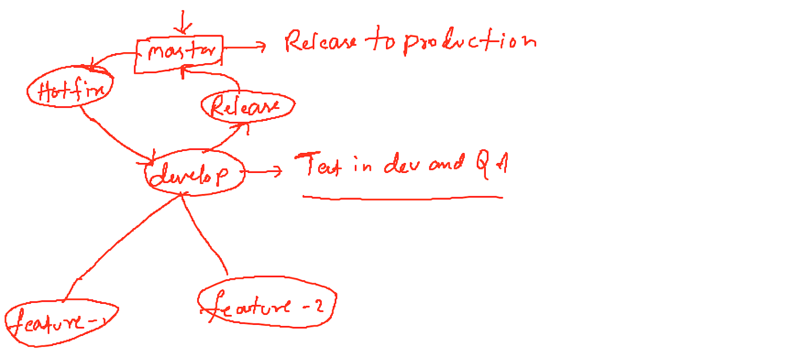

Feature Branch

1. This is created by developer for implementing new feature
2. This branch is created from develop branch
3. This is a temporary branch, and you delete this after merging pull-request.

Develop Branch

1. This serves as a merging point for feature branches
2. This is permanent branch and never deleted

Release Branch

1. Create a separate branch for every release, that should contain changes related to specific releases.

Master Branch

1. This is the master copy of our code, it should have tested and clean code.
2. Use this for releasing changes to production.

Hotfix Branch

1. This is used to fix production defects
2. This is created from master branch
3. Merge changes to develop/release branch for testing
4. Then merge to master and release changes.

(FAQ) What is a bare repository in Git?

Is a repository which does not have workin and staging areas, so we cannot directly make changes to this repository. This is used for setting up remote repositories.

(FAQ) What is the blame command in Git?

This command presents each line in the file with the developer details made those changes.

(FAQ) What is HEAD in git?

HEAD is lightweight pointer which usually points to latest commit in the current branch

(FAQ) Git Init

* Converts local folder into git repository
  + git init
* Sometimes we will have a normal folder and that we want to convert into a git repository.

(FAQ) Git Cherry Pick

* Cherry pick is related to merging commits
* Git merge will merge all commits and cherry-pick will merge specific commits.

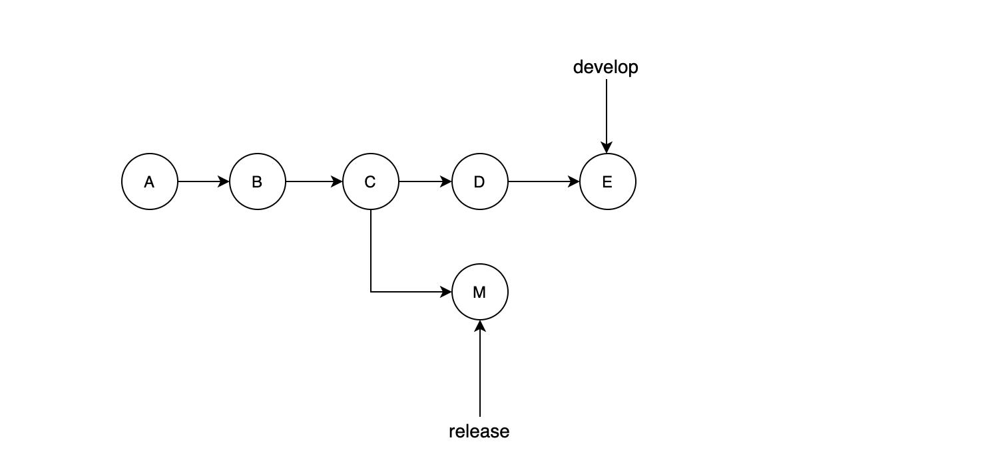

In the above diagram, I want to merge only commit (D) on to my release branch, then use cherry pick command.

The steps to use cherry pic

1. Be in the branch where you want to merge your commits
2. Run cherry pic command and give commit id

(FAQ) What is git stash?

Sometimes we will be working on a task, the changes will be in the working and index area, suddenly you got another high priority task to work on.

(FAQ) What is git tag?

Tag is a lightweight pointer like your branch, tag helps in marking specific commits, tag is used for releases.

Branch is used for adding/enhancing features and fixing defects.

What is git hook?